Issues identified of the HRM-Payroll System as of 4.12.2012

1. Login Screen allows blanks for Username and Password fields

2. Registration user page

|  |  |  |
| --- | --- | --- |
| **Current Fields** | **Requirement** | **Reason** |
| Name  Designation  Institution  Username  Password  Re-enter Password | Full Name of System user  Designation  **Contact cellular number**  (validate 10 digits, 077,071,075,072,076 first digits)  **Name of accountant**  **Contact cellular number**  (validate 10 digits, 077,071,075,072,076 first digits)  Institution (From the drop down list)  Username **(an Email address, with a verification step)**  Password  Re-enter Password  **Number of Payroll ‘SETS’**  **Register by individual names**  Total should match the number in the list  **Authorization code** (To be sent with the circular)  Need to validate ; mathematically/against database | Data entry person should not be the accountant (Better compliance)  Emails verified for ease of contacting  Cellular numbers of both the accountant and system user to give reminders |

3. Login to allow only users with validated email to enter.

If failed, redirect to a screen displaying contact details of the system admin to reset the user registration.

4. Menu

|  |  |  |
| --- | --- | --- |
| Current Menu items | Requirement | Reason |
| Home  View Data  Institution Employees  Upload  Upload from payroll software  Edit Metadata  Institution Types  Institution  Designations  Designation Category  Admin  Activate accounts  Manage Accounts  Edit  Users  Change Password  Preferences | Home  Should be a dashboard with last month’s summary  Month  File upload date  Designation  Count  Total  View Data  **1. Summary by month**  Ability to select the required month (Dropdown preferred)  Month  File upload date  Designation  Count  Total  *Download as Excel*  **2. Full list by month**  Month  File upload date  Name  NIC  Designation code  Designation  ‘Matched designation’  *Download as Excel*  **3. Pending data institutions**  Institution  Accountant  Tel number (Accountant)  System user  Tel number (User)  Email address (username)  SETS not received  *Download as Excel*  **Admin**  ~~Activate accounts~~; No need as email and verification code used.  1. Manage Accounts  Should be able to;  delete accounts  request password reset  2. Add institutions  3. Edit Institutions  Institution name  Institution code  Is adequate for items 2&3  5. Add ‘Matched Designation’  4. Reconcile Designations  Payroll file  **F1_DESIG**  **F1_SERVICE**  Against  ‘Matched designation’  Show currently pending list and  Already matched list  ~~Designation category~~  **View Summary data**  **By Month**  Data submitted Institutions  Data not-submitted Institutions  Total counts for the month  Designation  Count  Counts per Institution  *Download as Excel*  **Upload payroll file**  Institution captured from the login  Select SETS from the dropdown list. (MD5 validation for duplicate file uploads)  Browse and upload button  **Users**  Change Password  Preferences |  |

Have also included the document I shared earlier

**HRM-Payroll reconciliation system meeting on 12.11.2012**

Participants;

Mr. Kapila Alwis, Treasury Official

Dr. S.R.U. Wimalaratne, Director Information

Director (Finance) Planning

Dr. C. Weerabaddana, Dr. Ravi Wickramaratne, Dr. Thilina Gunasekara (MOHI)

Outcomes;

1. For each paying institution, there can be multiple files/sets to that contain the necessary data.

These files can contain;

a. Personal handled by different accounts assistants

b. Different staff categories such as Medical Staff, Nurses, Minor staff, etc.

Eg: National Hospital has 26 such sets.

|  |  |
| --- | --- |
| Issue identified | Solution |
| 1. Need to identify the sets individually, so that reminders can be sent to upload only the missing sets. | 1. Register all the paying stations with contact information of the Accountant and a responsible officer.  2. Register the sets with descriptions/ names in the first login for the institution.  3. Request to select the correct set before uploading the file in subsequent uploads. |
| 2. Avoid uploading duplicates of the same file | 1. Use MD5 hashing to identify and duplicates. Reject/warn if found. |

2. To improve compliance on uploading

|  |  |
| --- | --- |
| Issue identified | Solution |
| 1. Poor compliance | 1. Make it a regular monthly task  2. Designated person with the contact information to send reminders.  3. Feedback at regular intervals  4. Provide summary statistics to the institutions |

3. Limit the scope to permanent staff

|  |  |
| --- | --- |
| Issue identified | Solution |
| 1. How to identify permanent staff | 1. Have a values for the F1_WOP and F1_CONSAL |

4. Limit the scope to staff drawing a salary (Personal on ‘No pay’ leave will not be counted)

|  |  |
| --- | --- |
| Issue identified | Solution |
| 1. How to active salary drawing staff | 1. F1_STAT should be set to 0 (Zero) |

5. Identify the working institution of each employee

|  |  |
| --- | --- |
| Issue identified | Solution |
| 1. No standard list of institutions and the institution is inserted into the database as free text | 1. Use a composite of F1_OFADDR1 + F1_OFADDR2 + F1_OFADDR3 as the institution.  2. Map the composite to the list of institutions maintained by the Planning unit of the Ministry. |

6. Identify the designation of each employee

|  |  |
| --- | --- |
| Issue identified | Solution |
| 1. Incomplete list of categories in the database  2. Free text used to identify the sub-categories  3. Incomplete set of grades for each category which is not updated regularly | 1. Try to update the category list of the treasury to include all major designations. (F1_SERVICE)  2. Try to map to the Ministry identified list of designations from the values in F1_DESIG and F1_SERVICE)  3. Use the discrepancy of basic salary among grades to select the correct grade. Device modular way to do the grading for future expansion. |

**Summary reports**

Reports to be generated for different administrative levels;

1. Institution
2. Paying station
3. RD
4. PD
5. Line Ministry/ Provincial
6. Total

Content of the summary reports

1. Category Vs Numbers
2. Age distribution of the categories

Minutes of discussion 17.1.2013

Participants;

Chaminda

Buddhika

Key points;

1. Have three user levels

http://yuml.me/diagram/scruffy/usecase/draw

// Cool Use Case Diagram

[System admin]-(Add Institutions)

[System admin]-(Add Ins Admins)

[System admin]-(Add Inst. Users)

[System admin]-(upload file)

[System admin]-(View All Reports)

[Super User]-(View All Reports)

[Inst. Admin]-(Add Inst. Users)

[Inst. Admin]-(upload inst. file)

[Inst. Admin]-(View Inst. Reports)

[Inst. User]-(View Ins Reports)

[Inst. User]-(upload inst. file)

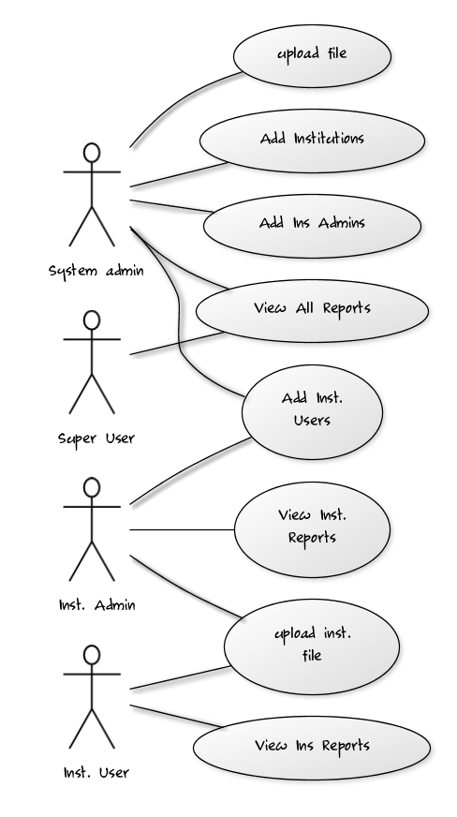

Login Page

Home page

System Admin

List of inst. Pending file upload

Security alerts

Super User

View All Reports

Inst. Admin

List of ‘sets’ Pending upload

Current registered inst. users

Inst. User

View inst. Report

File upload page

Parameters enable on the user privilege level

Inst. Selection – System Admin

Set Selection – inst. User

File upload acknowledgement page

Issues identified

Eg: entries without NICs / Designation code/ Designation

Captured data view

Index of relatedness to set (previous month)

Confirmation request to accept upload

To homepage on accepting

To file upload page on rejection

Inst. List update

Manage users

Inst. or country lists on Privilege level

[System admin]-(Add Institutions)

[System admin]-(Add Ins Admins)

[System admin]-(Add Inst. Users)

[System admin]-(upload file)

[System admin]-(View All Reports)

[Super User]-(View All Reports)

[Inst. Admin]-(Add Inst. Users)

[Inst. Admin]-(upload inst. file)

[Inst. Admin]-(View Inst. Reports)

[Inst. User]-(View Ins Reports)

[Inst. User]-(upload inst. file)

To do list;

Chaminda ;

Menu structure update

Inst. Entering page

Buddhika;

Designation/Service type

Entities to be added

Client inst. List – institution name : composite of 3 lines (String)

Paying center name

Auto_id

To do Buddhika

1. Upload excel for designations

2. Sets of Institutions to create

3. Login error

4. Set, Year and Month in File Upload

5. Privilege – changed from user type to user role

Enable restrictions

6. Mapping designation from the Payroll to HRM

7. Record Summary for upload page and home page

To Do Chaminda

1. Institutions

IsPayingInst

payedBy 🡪 Automatics population

isOfficial

2. Institutions mapping

InsitutionMapping Page

MappingAlert() …………non mapped insts